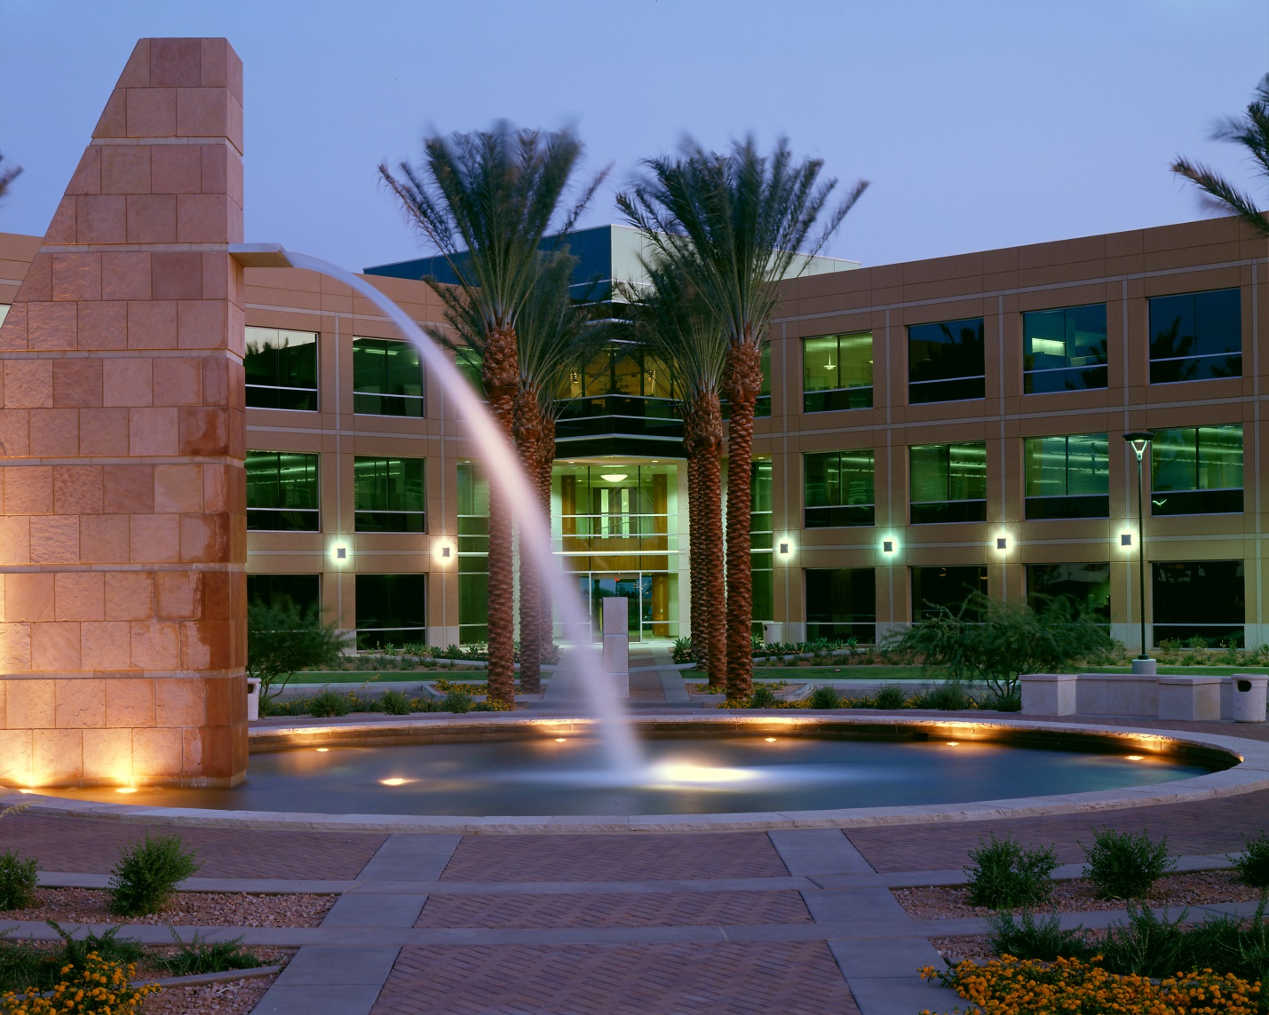

The Pinnacle in Kierland
Phase I
Tenant Manual
14624 N. Scottsdale Rd.
Scottsdale, AZ 85254

Contents
- Welcome
- Office Staff
- Maintenance Staff
- Building Hours
- Policies
- Janitorial
- Service Orders – Repairs and Maintenance
- Tenant Vendors
- Holidays
- Smoking
- Tenant Insurance
- Locksmiths
- Fire & Life Safety Procedures
- Fire
(Areas of Refuge, Emergency Exits/Stair Locations)
- Bomb Threats
- Natural Disasters
- Medical Emergency
- Workplace Violence

- Welcome to Furst Properties, LLC:

Furst Properties would like to take this opportunity to welcome you to our family of commercial tenants. We are excited you have selected a Furst Property and look forward to a long lasting relationship. Enclosed in this manual, you will find important information regarding our building policies and procedures, contact information for our staff and emergency measures. We are very happy you are a part of our family.

- Office Staff

Furst Properties, LLC office is located at 14648 N. Scottsdale Rd., Suite 140. Office hours are 8:00 a.m. to 5:00 p.m., Monday through Friday, excluding holidays.

Postal Address:
14648 N. Scottsdale Rd.
Suite 140
Scottsdale, AZ 85254
Telephone: (480) 951-9550
Fax: (480) 951-0665
Website: www.furstproperties.com

- Tammy Gibbons – Vice President of Property Management, Designated Broker
tgibbons@furstproperties.com
- Crystal Edwards – Senior Property Manager
cedwards@furstproperties.com
- Christy Kruegel – Property Manager
ckruegel@furstproperties.com
- Linda Bassett – Controller
Lbassett@furstproperties.com
- Kathy Carpenter – Executive Assistant
kcarpenter@furstproperties.com

- Maintenance Staff

- Chad Butler – Chief Engineer
- George Shamoon – Assistant Chief Engineer
- Doug Bogle – Engineer
- Brandon Davis – Engineer

- Building Hours
All building lobby doors unlock at 7:00 a.m. and re-lock at 6:00 p.m. Heating Ventilating and Air Conditioning (HVAC) is provided during business hours, which are from 7:00 a.m. - 6:00 p.m. Monday through Friday, and from 7:00 a.m. – 1:00 p.m. Saturdays.

- Weekends
All garage gates and building lobby doors are locked and available by card access only.
HVAC provided from 7:00 a.m. – 1:00 p.m. Saturdays. After-hours HVAC available by over-riding thermostat (instructions attached). All after hours HVAC is billed $10 per hour per unit.

Management/Engineer available on emergency basis – Please call the Maintenance Office at #480-951-9550 and follow the after-hours instructions.

- Policies

- Janitorial
The janitorial crew cleans nightly, Monday through Friday. They have been instructed not to throw away anything that is not in a trash can unless it is labeled “trash”. Signs that are easily recognizable to the janitors are available for this purpose.

Please call the Property Manager if you have any special cleaning requests or complaints. Though we both communicate with the janitorial supervisor, management must be made aware of any special requests or repeated problems. In addition, we are not able to fully monitor their service if we are unaware of your complaints.

- Service Orders – Repairs, Maintenance, Access Card & Key Requests

Requests for maintenance items such as hot/cold calls, lights out, should be entered into the Yardi Work Order System. It is helpful if one person in your office is designated to make these requests for two reasons; 1. Your employee’s time is not wasted in making multiple calls for the same item and 2. We have one contact person for direction.

If a request will generate charges to you, we will provide an estimate and have you sign an authorization form prior to performing the work.

Any work in the tenant space required by the tenant needs to be coordinated with the Property Manager. This is especially true of any electrical, plumbing or mechanical work and for best results, any decorating work to insure that correct building standards and rules are followed and adequate insurance is obtained. Additionally, this will ensure a smooth work flow and minimize problems for the tenant and building staff.

- Tenant Vendors

Vendors brought in by a tenant (i.e. furniture movers, telephone/computer/cabling companies) must be approved by the Property Manager and must provide a Certificate of Insurance. Please contact your Property Manager for specific requirements. If large items are being brought in or out of the building, please coordinate with the Property Manager to have a designated elevator set up with padding. Also furniture movers should provide Masonite for floor protection, cardboard and or blankets for wall and granite protection and they should remove all moving cardboard boxes from the building.

Any damage to the building caused as a result of a tenant’s employee and/or vendor is ultimately the responsibility of the tenant.

- Holidays

The official holidays are: New Year’s Day, Memorial Day, Independence Day, Labor Day, Thanksgiving Day, and Christmas Day.
On these days all building doors are closed and locked. Access to the building will be by access card only. Building and Maintenance staff is off duty except on an emergency basis. HVAC runs on their normal schedule.

- Smoking

Furst Properties, LLC and The State of Arizona, prohibit smoking inside suites and all common areas of the building, including the lobbies, corridors, restrooms, elevators, garages, balconies and at least 20 feet from building entries. Smoking is permitted in fountain area, ashtrays are provided where smoking is permitted.

- Tenant Insurance

As stipulated in the lease, tenants must have active insurance at all times. Furst Properties requires an insurance certificate detailing your coverage and a “Additional Insured” Endorsement before you assume tenancy and annual insurance renewals must be forwarded to our office to ensure continuous coverage. (See the “Tenant Insurance” section in your lease for appropriate coverage and requirements.)

- Locksmiths

All door locks installed by a tenant, whether on exterior or interior doors, must be keyed to the base building master system to permit emergency access and normal cleaning activities.
Furst Properties Management Office maintains the master system and all records relative to key and card access programming and distribution. No outside locksmiths or manufacturers may alter the keying of locks. All keying, keys and cards must be requested through Furst Properties. There are service charges for supplying and cutting additional keys, cards, re-keying cylinders and repairing lock hardware.

HVAC INSTRUCTIONS
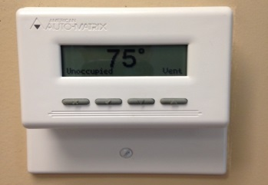

The HVAC automation system installed in your suite has thermostats that look like the picture above. There are 4 buttons near the bottom that are used for making adjustments to the system. The button with the X on it is a “go back” or “esc.” The button with the check mark = √ is used for turning the overtime air on and off (See instructions below), and the up and down arrow buttons are for adjusting the temperature.

In the window you will see the room temperature in the center. In the lower left you will see either “Unoccupied” or “Occupied” which indicates the status of the Overtime Air, Occupied means “ON”.

If you press either of the up or down arrow buttons, you will see the setting of the temperature adjustment and by pressing these buttons you can adjust the temperature up or down a total of 5 degrees = 2.5 degrees either way.
WARNING = If you press the up or down buttons after hours, you will start Overtime Air.

TO START OVERTIME AIR AFTER HOURS

Press the check mark = √ button to see a menu, and then press it a second time to turn on Overtime Air. On the screen you will see a √ by the “Occupy Override” showing it is on. It is programed to automatically turn off after 2 hours. If you need more time, restart it. You can also turn it off by using the √ button and make the √ go off by “Occupy Override.”

If you are in a menu screen, it will go back to temperature in a short while. If you want it to go back immediately then press the X button.

- Fire & Life Safety Procedures

- Fire
Any smell of smoke should be immediately reported to the Building Management at #480-951-9550. Any occupant has the authority to call, remain calm. Do not attempt to trace the source of the smoke before calling. Building evacuation is necessary when a Fire Alarm Signal is sounded.

Each tenant Office Manager or Supervisor must predetermine priorities for the safety of records, classified material or securities. They must ensure that all employees are well-informed and instructed on evacuation procedures.

Procedures:
- Remove all people from immediate danger by evacuating to the nearest stairwell.
- Call the Fire Department IMMEDIATELY – dial 911.
- Inform the Fire Department dispatcher that you are calling to report a fire at 14624 North Scottsdale Road. Be ready to give the following information:
- Your name
- Your company name
- Your suite/floor number
- What is on fire
- The location of the fire
- Your telephone number
- Listen to the Dispatcher for any additional instructions before hanging up.
- Call the Management Office at #480-951-9550.
- All elevators are called to the ground floor and put on manual control.
- Unless a stairway is on fire or smoke-filled, people should calmly and quietly exit using the stairwell.
- To avoid lobby congestion, please continue outside.
- The alarm signal continues throughout the state of emergency.
- When the “All Clear” is announced by the Fire Department or Property Manager, depending on the emergency, all employees will go in an orderly fashion back to their work places. If available, elevators will be back in service.
- The intermittent Alarm Signal is silenced when the “All Clear” is announced.

Tenant Responsibilities
- Become familiar with the Life Safety Procedures and attached Evacuation Plan found in your Tenant Manual and review it with all employees. The Manual should be kept in a location readily accessible to all personnel.
- Turn off all appliances, coffee makers, etc…when not in use – especially at the end of the day.
- Use of personal electric heaters, i.e. “space heaters” is prohibited.
- Do not store flammable materials in your suite.
- Make all personnel aware of risks involved with items such as smoldering cigarettes in ashtrays or wastebaskets.
- Bring potential risks to the attention of the The Building Management.
- When the fire alarms sound, all occupants shall, without delay, follow emergency evacuation procedures.
- Participate in scheduled fire drills. The City of Phoenix Fire Department requires that occupants vacate the building during a fire drill. In the event the alarm sounds, please instruct all employees to vacate the building to the Area of Refuge (See attached map)

Building Management Responsibilities
- Notify the Fire Department of any fire or fire alarm.
- Bring all elevators to the ground floor.
- The Fire Department is given all emergency keys.
- Insure evacuation procedures are followed.
- The conditions on the fire floor are reported to the Fire Department
- Provide the Fire Department and Police Department with building information (floor plans, blue prints, etc…) as requested.

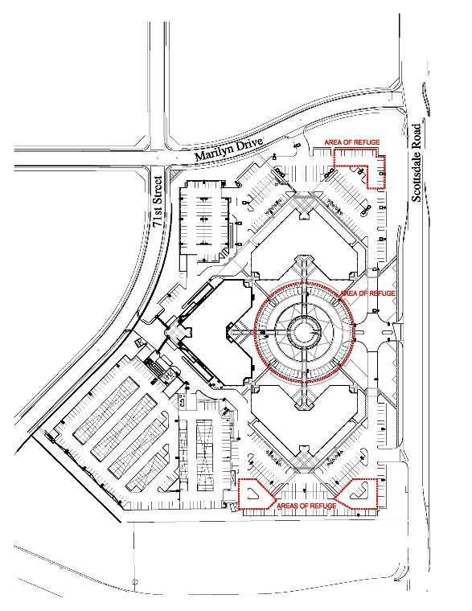

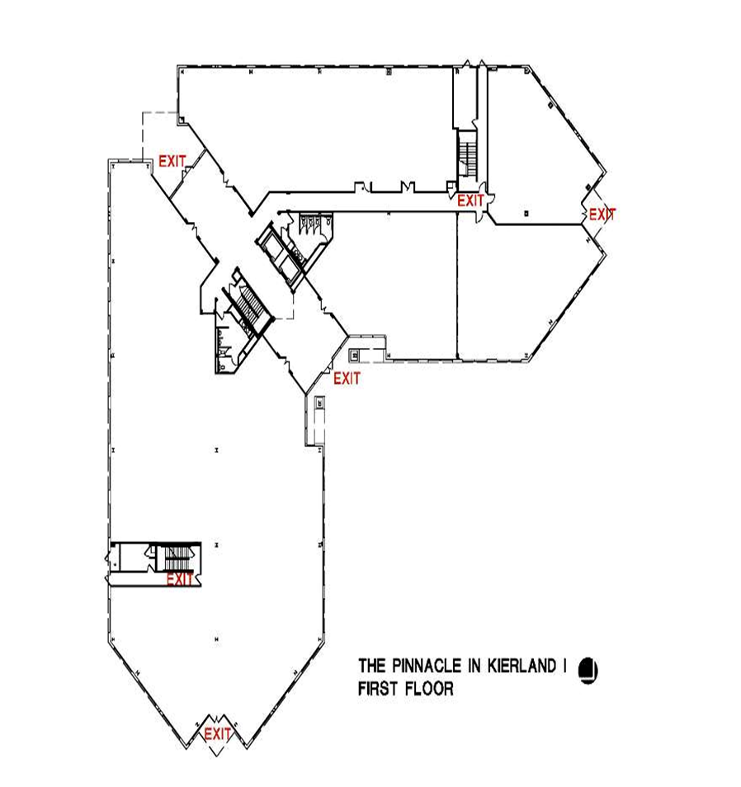

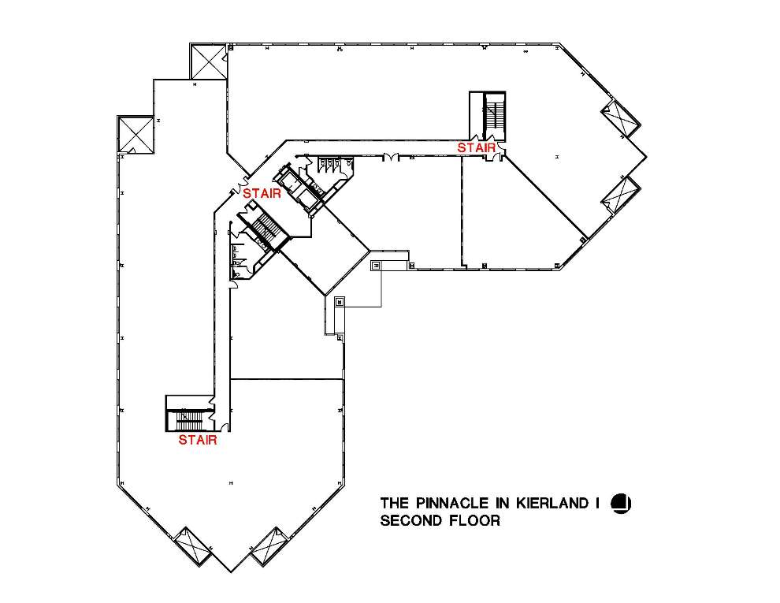

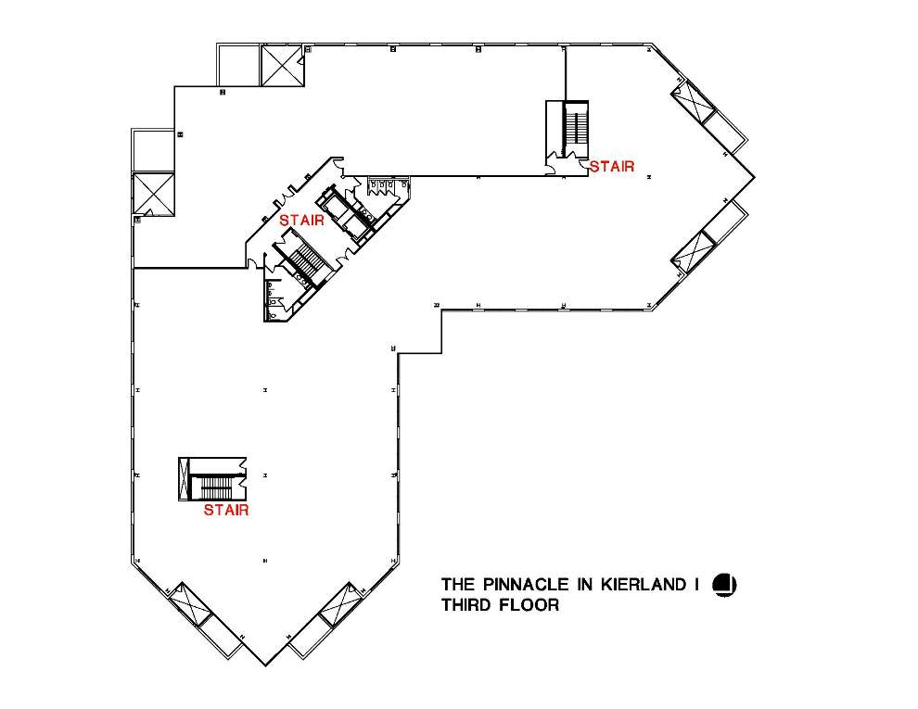

- Bomb Threats
If a bomb threat is received verbally, immediately call 911. Give the address, 14624 North Scottsdale Rd. and your office and floor number. Most bomb threats are made by direct telephone calls to a company or the police. However, some bomb threats are delivered to third parties such as television stations or newspaper offices.

Most bomb threats are false, but there is no way to tell a hoax from the real thing. Therefore, all calls must be taken seriously.

It is important to accurately record bomb threats. All employees who answer incoming calls should be given a Bomb Threat Checklist (See attached). If you receive a bomb threat, the most important thing to remember is to remain calm. Encourage the caller to keep talking by being friendly and using words such as “okay”, “yes”, “I understand”, etc… Some callers will give considerable information if asked the proper questions.

During the call:
- Do not interrupt the caller while he/she is talking.
- In general, do not argue or be antagonistic.
- Note the caller’s exact words.
- Listen for background noises.
- Try to obtain the caller’s name and any other pertinent information.

Threats against a corporation and its personnel can come through delivered mail or parcels. All employees should be alert to this type of nonverbal threat and take precautionary measures to detect such dangers. When a written bomb threat is received, save all materials including the envelope or container. Once the message is recognized as a bomb threat, any further handling should be avoided. Every possible effort must be made to retain evidence such as fingerprints, handwriting, paper or postal marks. These will prove essential in tracing the threat and identifying the writer.

The most common indications that a letter or parcel might contain explosives are:
- Unusual bulk or weight
- Chemical or oily stains
- No return address
- Protruding wire or metal foil
- Emission of a peculiar odor

If you have any reason to believe that a letter or parcel is suspicious, do not take a chance or worry about possible embarrassment. It is not worth the risk.

Procedures:
- Call 911 and give the address 14624 N. Scottsdale Rd., Scottsdale, your office and floor number.
- Call the Management Office at #480-951-9550.
- Keep employees clear of the item.
- Do not handle the item.
- Do not attempt to open the item.
- Do not place the items in water.
- Do not remove any binding material.
- Do not pull or cut any material that protrudes.
- Do not place the item in a confined space.

BOMB THREAT CHECKLIST

Questions to ask the caller:
When is the bomb going to explode? ______________________________________________________________________________________
Where is it right now? ______________________________________________________________________________________________________
What does it look like? _____________________________________________________________________________________________________
What kind of bomb is it? ____________________________________________________________________________________________________
What will cause it to explode? _____________________________________________________________________________________________
Did you place the bomb? ___________________________________________________________________________________________________
Why? _________________________________________________________________________________________________________________________
What is your address? ______________________________________________________________________________________________________
What is your name? _________________________________________________________________________________________________________

Complete after the call is terminated:
Description of caller: Male Female Age: ______ Race: _______
Date of Call: _________________________________
Approximate Start Time: _____________ Approximate End Time: ________________

Caller’s Voice: (Check all that apply)
 | Calm |  | Raspy/Clearing Throat |  | Nasal
 | Angry |  | Slurred |  | Stutter
 | Excited |  | Normal |  | Disguised Accent
 | Slow |  | Crying |  | Deep Breathing
 | Rapid |  | Laughing |  | Distinct
 | Soft |  | Ragged |  | Lisp
 | Loud |  | Deep

If voice is familiar, whom did it sound like? ___________________________________________

Background Sounds: (Check all that apply)
 | Street Noises |  | House Noises |  | Local
 | Static |  | Factory Machinery |  | Long Distance
 | Voices |  | Motor |  | Clear
 | PA System |  | Office |  | Music
 | Animal Noises |  | Train |  | Other

Threat Language: (Check all that apply)
 | Incoherent |  | Irrational |  | Well spoken (Educated)
 | Foul |  | Taped |  | Message read by caller

- Natural Disasters
Natural disasters such as severe weather are potential threats in the Phoenix metropolitan area. The following suggestions and areas of responsibility are designed to provide for the safety of all, minimize the loss of assets and reduce the disruption of normal operations.

Severe Weather:
The US Weather Service reports the movement of severe weather that may present a threat to the Phoenix metropolitan area. It is likely that a great number of persons would be in the building during severe weather. Tenants have the choice of evacuating or remaining in the building during a severe weather alert. If an early alert is given by the US Weather Service, certain steps can be taken to prepare for the severe weather if the decision is to remain.

Tenant Responsibilities
- Maintain inventory of emergency equipment to be used during sever weather, i.e. Flashlights and fresh batteries and First Aid Kits.
- If informed by the US Weather Service that severe weather is imminent, the following steps may be necessary:
- Clear desks, tables and windowsills of books, papers or other items and secure them in boxes or drawers.
- Move easily moveable furniture away from windows.
- Store all easily movable office equipment in inside offices.
- Move all employees to the core areas of the building, i.e. stairwells, corridors)
- During the storm, all severe leaks, fires or structural damage are reported immediately to the Property Management #480-951-9550.
- After the storm, all safety hazards such as exposed wiring, broken glass, downed trees, etc… are reported to the Property Management Office #480-951-9550

Building Management Responsibilities
- Check the readiness of auxiliary power for emergency lighting, which has battery back-up.
- Move unattached building items indoors.
- Monitor local news and weather reports
- Building repairs are made as quickly as feasible.
- Communications are maintained with Public Utilities as appropriate

Power Failure
In the event the building sustains a power failure, emergency lighting is available in all stairwells. All HVAC equipment, lights, receptacles, elevators and most telephone equipment will not be operational.
The Building Management will be contacting Arizona Public Service to find out the duration of the power outage. If the electric company does not know how long the power will be out, or if power will be out for longer than one hour, the building may need to be evacuated.

Earthquakes
In the event of an earthquake, REMAIN CALM, do not attempt to leave the building. You are safer in the building until the initial tremors subside. Take cover under a desk or other sturdy object or against the wall in the core of the building. Protect your head, duck, cover and hold. Move away from building exterior, windows, bookcases, filing cabinets and any objects that may fall or shatter.

Procedures after an Earthquake:
- Check for injured and assist if possible. Do not move a seriously injured person unless they are in immediate danger.
- Inspect your floor for damage. Check for fires, gas and water leaks, and electrical shorts.
- If you suspect a gas leak contact the Property Management Office immediately #480-951-9550. DO NOT use matches, lighters or turn on electrical switches or appliances.
- Open doors carefully and watch for falling objects.
- Stay away from windows/glassed areas.
- Replace telephone receivers, in case the telephone system works. Use telephones for emergency calls ONLY.
- Cooperate with the Property Management Office and Public Safety Officials.
- Be prepared for aftershocks.
- Notify the Property Management Office of any damage to the building.

- Medical Emergencies
Building tenants should follow the procedures listed below if a medical emergency is encountered:
- Remain with the victim and call out for assistance.
- Do not attempt to move the individual, unless they are in immediate danger.
- Call 911
- State the nature of the emergency
- State the building’s address – 14624 North Scottsdale Rd.
- State your company name, suite number and floor number.
- Answer all questions of the 911 operator.
- Do not hang up until the operator tells you to do so.
- Call the Property Management Office #480-951-9550 and give exact location and nature of the emergency, so that they can be prepared for the arrival of the emergency vehicles.
- Be prepared with the name and phone numbers of any emergency contacts of medical victim, i.e. spouse, parents, children, etc…

- Workplace Violence
According to the US Dept. of Justice, workplace violence falls into four broad categories

Type 1: Violent acts by criminals, who have no other connection with the workplace, but enter to commit robbery or another crime.

Type 2: Violence directed at employees by customers, clients, patients, students, inmates or any others for whom an organization provides services.

Type 3: Violence against coworkers, supervisors, or managers by a present or former employee.

Type 4: Violence committed in the workplace by someone who doesn’t work there, but has a personal relationship with an employee – abusive spouse, domestic partner, stalker etc…

Many times, a violent act is preceded by a threat. The threat may have been explicit or veiled, spoken or unspoken, specific or vague, but it occurred. In other instances, behavior may be observed by others, which might suggest the potential for some type of violent act to occur. Yet in other cases, it may be the off-handed remark or comments made to people close to the individual, which may suggest problematic behavior. Dealing with threats and/or threatening behavior – detecting them, evaluating them, and finding a way to address them – may be the single most important key to preventing violence.

If you or one of your employees, feel unsafe for any reason, please notify the Property Management Office #480-951-9550 so we can inform our security and maintenance staff to be on high alert.

